EBS volume LAB
EC2 instance created with root/EBS volume
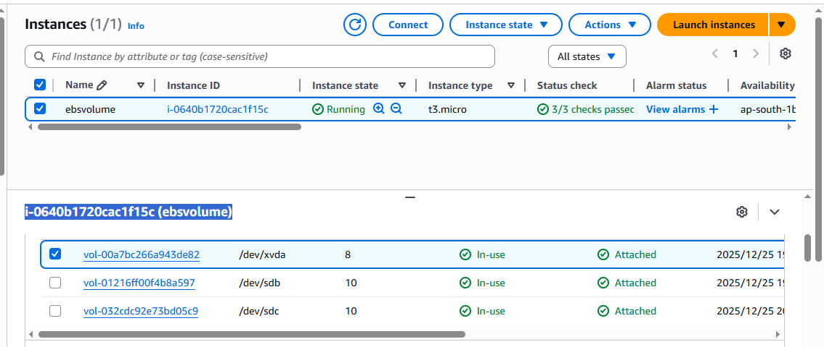

Login to in EC2 instance
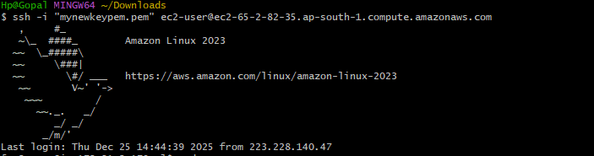
Switch in the root user sudo su and checked disk filesystem
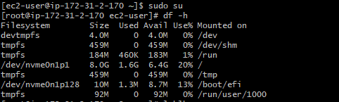
lsblk ---- list of block devices of EBS volume

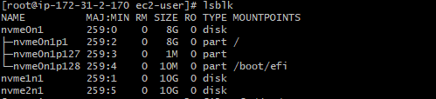
File -s /dev/nvme1n1 ---- to check the data in particular device (EBS volume) to format
Formatted EBS volume /dev/nvme1n1
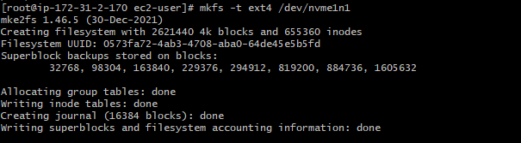

Directory has been created and also mounted to particular EBS volume (/dev/nvme1n1)
Able to write a data in the disk
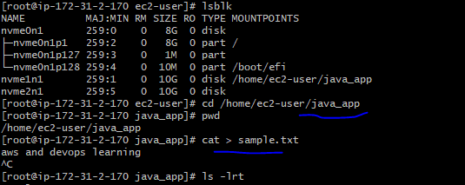
If we don’t want to lose the mount point after a server reboot, we need to add the mount point entry in /etc/fstab

